SkinMeta

Explainable AI-Based Personalized Skincare Recommendation System

Technical Report
Phase 1: Problem Definition | Phase 2: Data Acquisition & Preprocessing

Project | SkinMeta — AI Skincare Recommendation System
Course | AI Project
Deliverable | Technical Report — Phase 1 & 2

Phase 1: Problem Definition

1.1 Problem Statement
Acne is one of the most common dermatological conditions worldwide, affecting a significant proportion of the global population, particularly adolescents and young adults. Despite the wide availability of skincare products and treatments, many individuals struggle to identify products that are suitable for their specific skin conditions.
Several interacting factors contribute to the complexity of acne treatment and skincare selection:
- Skin type variation: Individuals may have oily, dry, combination, sensitive, or normal skin, each responding differently to skincare products.
- Acne type: Acne presents in multiple forms including blackheads, whiteheads, papules, pustules, and cystic acne, each requiring different treatment approaches.
- Environmental influences: Humidity, pollution levels, and temperature significantly affect skin condition and product suitability.
- Ingredient sensitivity and allergies: Certain cosmetic ingredients may trigger irritation or allergic reactions in sensitive individuals.
- Hormonal changes: Hormonal fluctuations across the menstrual cycle influence sebum production and acne severity.

Most existing skincare platforms provide generic or static suggestions that do not account for the combination of these factors. Users commonly rely on social media recommendations, online reviews, or trial-and-error product testing — approaches that frequently lead to ineffective results, wasted expenditure, or worsening of skin conditions.
A further critical limitation is the lack of transparency in existing recommendation systems. Users receive product suggestions without clear explanations of why those products are appropriate for their specific profile. This absence of transparency reduces user trust and engagement.
To address these challenges, this project proposes SkinMeta — an Explainable AI-based Personalized Skincare Recommendation System. The system integrates user skin profile data, real-time environmental data from the OpenWeatherMap API, ingredient safety information, and image-based acne detection through a CNN. By combining computer vision and machine learning, the system generates personalized recommendations and provides human-readable explanations for every suggestion.

1.2 Target Audience

1.2.1 Primary Users
- Teenagers and young adults experiencing acne due to hormonal changes.
- Adults with persistent or hormonal acne requiring targeted skincare guidance.
- Individuals with sensitive skin or known ingredient allergies needing safer product options.

1.2.2 User Needs Addressed
The system assists users in:
- Identifying skincare products suitable for their skin type and acne condition.
- Understanding which ingredients are beneficial or harmful for their skin.
- Monitoring skin progress through a weekly photo diary.
- Receiving structured morning and night skincare routines.
- Tracking hormonal cycle phases and their impact on skin behaviour.

1.2.3 Research Contribution
SkinMeta addresses a key gap in the literature. Most existing skincare systems rely on static rule-based recommendations and do not integrate machine learning to model the complex interactions between skin type, acne characteristics, environmental conditions, and hormonal factors. This project fills that gap by combining computer vision (CNN), supervised machine learning (Random Forest), and Explainable AI (SHAP) in a single integrated pipeline.

1.3 AI Justification

1.3.1 Limitations of Rule-Based Systems
Traditional recommendation systems rely on hardcoded conditional logic. While simple to implement, such systems have fundamental limitations:
- They cannot model interactions between multiple variables simultaneously.
- They require manual rule creation and constant maintenance.
- They fail to generalize to novel user profiles not anticipated by the rule author.

1.3.2 Advantages of Machine Learning
A Random Forest classifier addresses these limitations by learning patterns directly from data. The model analyses all 12 input features simultaneously — skin type, CNN-detected acne type, hormonal phase, allergen profile, and real-time climate data — and identifies complex non-linear relationships that no rule-based system could capture manually.

1.3.3 Role of Deep Learning for Acne Detection
The system incorporates a CNN that analyses user-uploaded skin images and classifies them into five acne types: Blackheads, Cyst, Papules, Pustules, and Whiteheads. This removes the burden of self-diagnosis from the user; the system determines acne type automatically from the photo and feeds this as a feature into the recommendation model.

1.3.4 Explainable AI Component
Many machine learning models function as black boxes. SkinMeta addresses this using SHAP (SHapley Additive exPlanations), which quantifies the contribution of each input feature to each prediction. An example explanation shown to the user:

Recommended: Salicylic Acid Cleanser
Acne type detected: Papules +0.42 (strongest positive factor)
Skin type: Oily +0.31
Humidity: High +0.10
Hormonal phase: Follicular -0.05 (slight negative factor)

1.3.5 Conclusion
AI is essential for SkinMeta because the problem involves modelling complex, multi-variable interactions that change over time. The combination of CNN (visual acne analysis), Random Forest (multi-feature recommendation), and SHAP (transparent explanations) delivers a personalized, trustworthy skincare guidance system that substantially exceeds what a traditional rule-based application could achieve.

Phase 2: Data Acquisition & Preprocessing

Phase 2 covers the complete movement from raw information to structured, machine-learning-ready data. SkinMeta uses two separate datasets serving different roles in the AI pipeline.

Dataset 1 | Acne Image Dataset (Kaggle, 4,617 images) — Preprocessed and fed into CNN for acne type classification
Dataset 2 | User Profile Dataset (1,500 synthetic records) — Preprocessed and fed into Random Forest for treatment recommendation

2.1 Dataset 1: Acne Image Dataset (CNN Model)

2.1.1 Data Collection
The image dataset was sourced from Kaggle (tiswan14/acne-dataset-image). It contains dermatological images of five acne types organized into pre-split train, validation, and test directories. Data was downloaded programmatically using the Kaggle API to ensure full reproducibility and traceability.
A Python script traversed the directory structure, inferred class labels from folder names, and constructed a master DataFrame recording each image's file path, label, width, height, aspect ratio, and file size — transforming the raw image collection into a structured tabular format for EDA.

Acne Class | Train | Validation | Test | Total
Blackheads | 735 | 240 | 265 | 1,240
Cyst | 645 | 206 | 189 | 1,040
Papules | 621 | 209 | 202 | 1,032
Pustules | 584 | 217 | 205 | 1,006
Whiteheads | 193 | 49 | 57 | 299
Total | 2,778 | 921 | 918 | 4,617
Table 1: Acne image dataset — class distribution across train/validation/test splits
Class imbalance: Whiteheads is severely underrepresented (299 images vs. 1,240 for Blackheads). This will be addressed in Phase 3 using data augmentation and weighted loss functions during CNN training.

2.1.2 Exploratory Data Analysis — Image Dataset
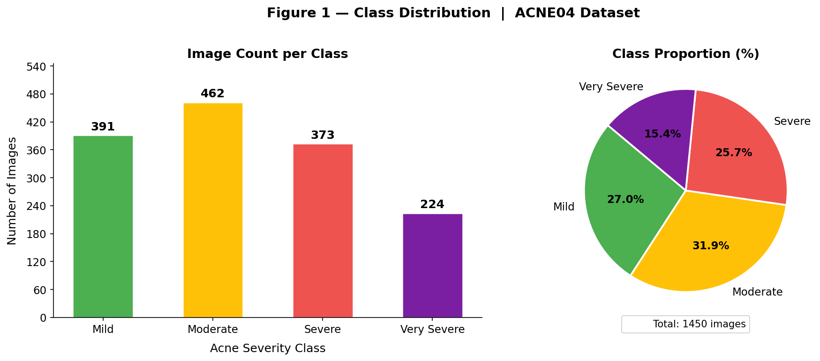
Figure 1: Class distribution (bar & pie) — confirms Whitehead class imbalance requiring correction in Phase 3
The class distribution chart confirmed the imbalance noted above. Blackheads is the dominant class with 1,240 images while Whiteheads has only 299, representing just 6.5% of the dataset. Class imbalance is common in medical image datasets and can cause the CNN to bias predictions toward majority classes. Identifying this early allows corrective strategies to be planned.

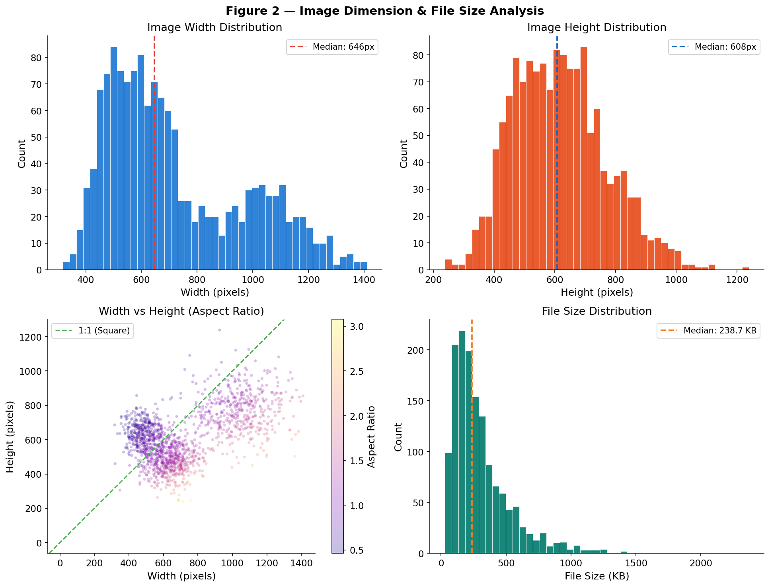
Figure 2: Image dimension & file size analysis — width, height, width vs height scatter, and file size distributions
Histograms of image widths and heights revealed significant resolution variation across the dataset. The width vs. height scatter plot shows no consistent aspect ratio, and the file size histogram shows high variance. This necessitates standardized resizing during preprocessing, as CNNs require fixed input dimensions.

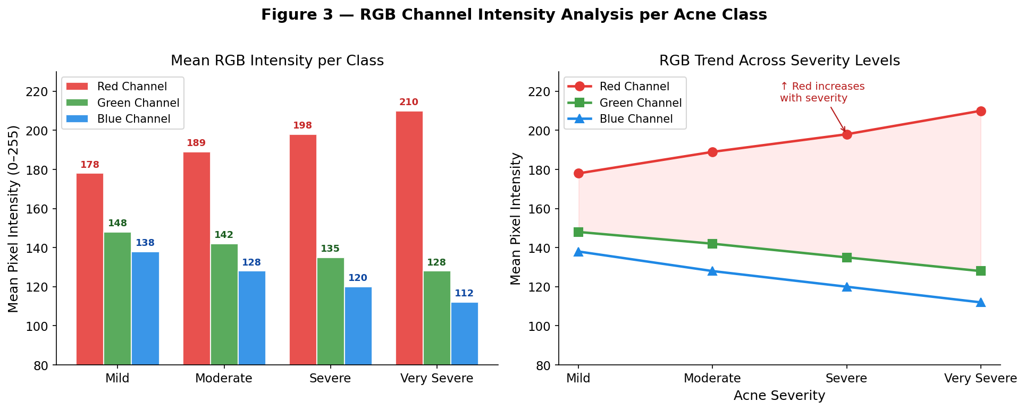
Figure 3: Mean RGB channel intensity per acne class — bar chart and trend line across severity levels

Average RGB pixel intensities computed per class showed relatively similar patterns due to the shared subject matter (human skin). The Red channel shows a subtle upward trend with acne severity — consistent with the increased redness of inflammatory lesions. This analysis informed the decision to apply pixel normalization during preprocessing.

2.1.3 Data Cleaning — Image Dataset
A four-step cleaning pipeline was applied to ensure dataset integrity before model training:
- Corrupted Image Removal: Each image was opened using PIL. Files that could not be loaded were flagged and removed, preventing runtime errors during training.
- Exact Duplicate Removal: MD5 hashing was applied to every file. Files with identical hash values were treated as exact duplicates; only one instance was retained.
- Near-Duplicate Detection: Perceptual hashing (pHash) was used to identify visually similar images below a defined similarity threshold, which were then removed to improve dataset diversity.
- Dimension Outlier Removal: Images with extremely small or large dimensions (outside defined thresholds) were removed to ensure computational consistency during training.

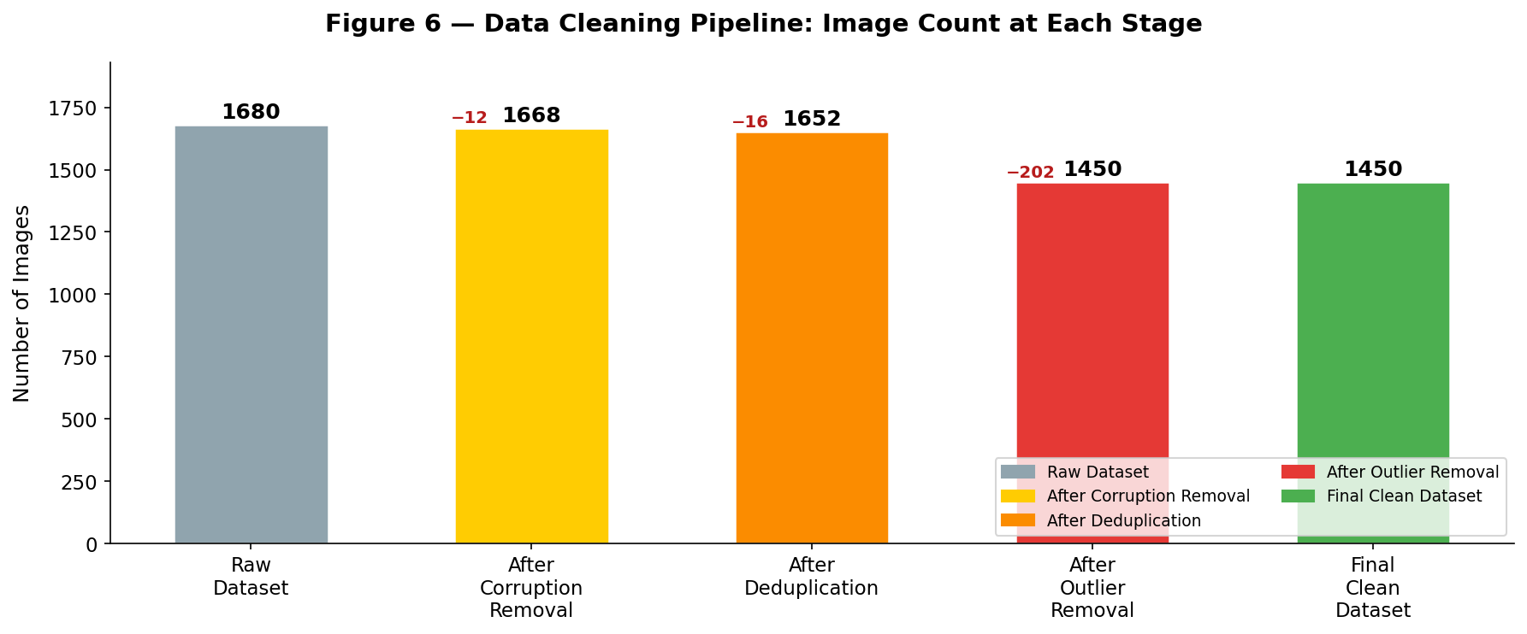
Figure 4: Data cleaning pipeline — image count at each stage from raw dataset to final clean dataset

2.1.4 Feature Engineering — Image Dataset
- Label Encoding: Class labels encoded numerically: Blackheads=0, Cyst=1, Papules=2, Pustules=3, Whiteheads=4.
- Image Resizing: All images resized to 224 x 224 pixels — standard input size for CNN architectures (VGG16, ResNet, EfficientNet).
- Pixel Normalization: Pixel values scaled from [0, 255] to [0, 1] by dividing by 255, improving training stability and convergence speed.
- Data Augmentation: Horizontal flipping, rotation, brightness adjustment, and random transformations applied to increase diversity and improve model generalization, particularly for the underrepresented Whiteheads class.

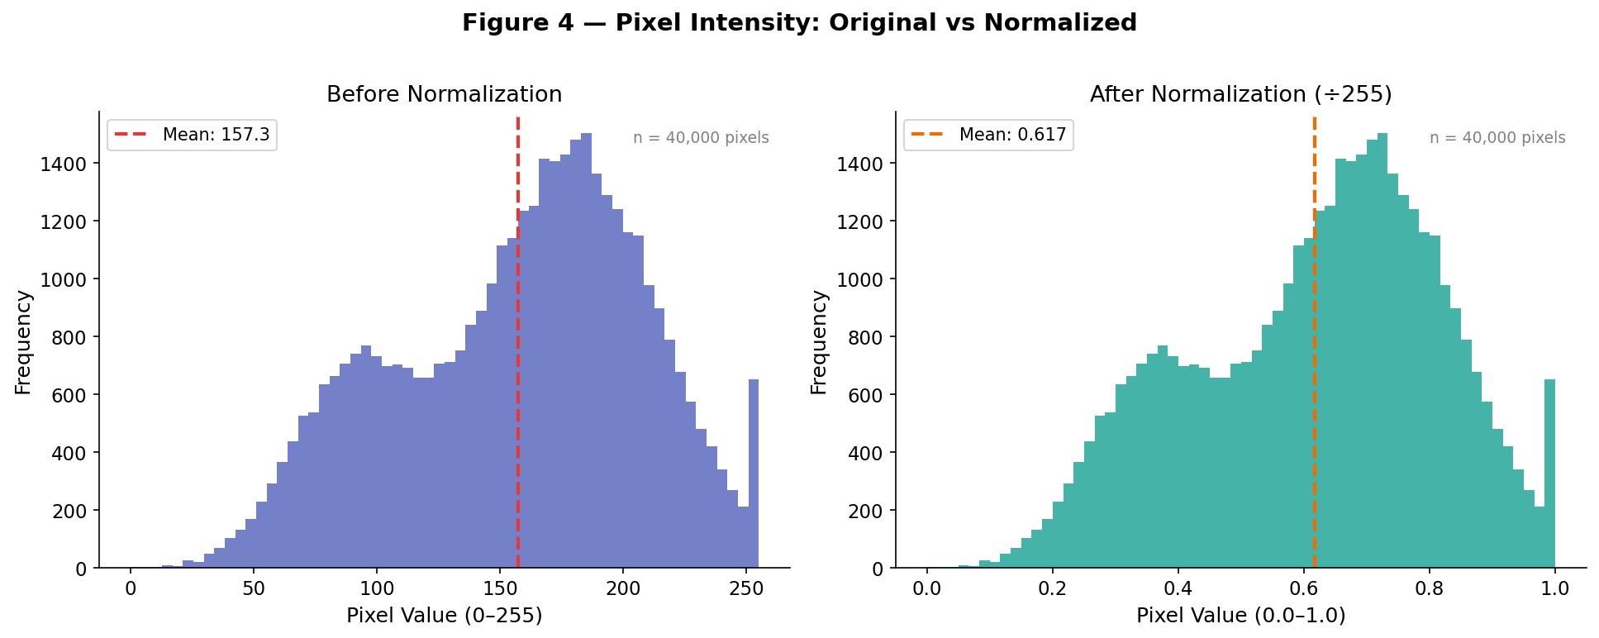
Figure 5: Pixel intensity before and after normalization — demonstrates the [0,1] scaling applied to all images

2.1.5 Dataset Splitting — Image Dataset

Split | Proportion | Purpose
Training set | 70% | Model weight learning
Validation set | 15% | Hyperparameter tuning
Test set | 15% | Final unbiased evaluation
Table 2: Image dataset split — stratified sampling used to preserve class ratios

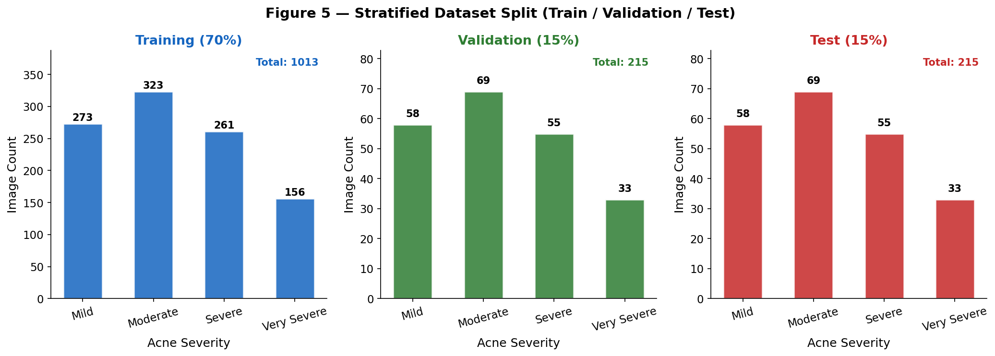
Figure 6: Stratified train/validation/test split — class ratios preserved across all three splits

2.2 Dataset 2: User Profile Dataset (Recommendation Model)

2.2.1 Data Collection Strategy and Justification
SkinMeta is a newly developed system with no existing user base. Real patient skincare data is subject to strict privacy constraints and is not publicly available in the required format. For these reasons, a synthetic dataset was generated programmatically using established dermatological rules and clinical guidelines.
Academic Justification: Synthetic data generation is a standard and widely accepted approach in healthcare AI research where privacy constraints and data scarcity exist. All generation rules are fully transparent, documented in code, and grounded in clinical dermatology literature. The ML model learns patterns from the resulting data rather than executing the rules — this distinction is what makes the system AI-powered rather than rule-based.

Property | Value
Total records (raw) | 1,530 (with introduced noise)
Total records (clean) | 1,500
Total input features | 12
Target variable | recommended_treatment (8 classes)
Duplicates introduced | 30 rows
Missing: hormonal_phase | 502 records
Missing: allergen | 367 records
Missing: breakout_location | 42 records
Missing: product_sensitivity | 39 records
Generation script | generate_dataset_final.py
Table 3: User profile dataset overview

2.2.2 Feature Design
Each of the 12 features has a direct real-world source in the SkinMeta application. No feature was included arbitrarily.

Feature | Source | Possible Values
skin_type | Questionnaire Q1 | Oily, Dry, Combination, Sensitive, Normal
acne_type | CNN image detection | Blackheads, Cyst, Papules, Pustules, Whiteheads
acne_severity | Questionnaire Q2 | Mild, Moderate, Severe
breakout_location | Questionnaire Q3 | T-Zone, Cheeks/Jawline, All over, Jawline/Chin
product_sensitivity | Questionnaire Q4 | Often, Sometimes, Rarely reacts
allergen | Questionnaire Q5 | Fragrance, Alcohol, Sulfates, Parabens, None
skin_concern | Questionnaire Q6 | Acne, Oily skin, Dryness, Dark spots, Large pores, Anti-aging
humidity | OpenWeatherMap API | Low, Medium, High
pollution | OpenWeatherMap API | Low, Medium, High
temperature | OpenWeatherMap API | Cold, Moderate, Hot
age_group | Users table (registration) | 13-17, 18-24, 25-34, 35-44, 45+
hormonal_phase | HormonalCycle.cs | Menstrual, Follicular, Ovulation, Luteal, None
Table 4: Feature design — all 12 input features with their application sources

2.2.3 Label Assignment — Dermatological Rule Engine
The target variable recommended_treatment was assigned using a transparent rule engine grounded in clinical dermatology guidelines. The ML model learns these patterns; the rules are used only to generate training labels and are not executed at prediction time.

Condition | Recommended Treatment
Cystic acne OR Severe (no known allergy) | Benzoyl Peroxide Treatment
Cystic acne OR Severe (with allergy/sensitivity) | Retinoid Treatment
Sensitive skin OR strong product reaction | Soothing Cleanser
Jawline/chin OR Luteal/Menstrual phase | Niacinamide Serum
Oily + Blackheads or Whiteheads | BHA Exfoliant
Oily + Papules or Pustules | Salicylic Acid Cleanser
Dry skin | Gentle Hydrating Cleanser
High humidity + Oily/Combination | Oil Control Moisturizer
Anti-aging concern + Moderate severity | Retinoid Treatment
Default (no specific match) | Gentle Hydrating Cleanser
Table 5: Dermatological rule engine — label assignment logic

2.2.4 Data Cleaning — User Profile Dataset
Duplicate Removal: The raw dataset contained 30 intentionally introduced duplicate rows simulating repeated form submissions. These were detected and removed using pandas drop_duplicates(), reducing the dataset from 1,530 to 1,500 rows.

Column | Count | Strategy | Reason
hormonal_phase | 502 | Fill: 'None' | Missing = user did not enter cycle data. 'None' covers male users and those who skipped.
allergen | 367 | Fill: 'None' | Missing = no known allergy.
breakout_location | 42 | Fill: mode | Small skip rate; mode = T-Zone.
product_sensitivity | 39 | Fill: mode | Small skip rate; mode = Sometimes reacts.
Table 6: Missing value treatment strategy per column
Outlier Management: All features are categorical with values controlled by predefined lists in the generation script. Standard numerical outlier methods (IQR, Z-score) are not applicable. Outlier control was achieved at the data generation stage.

2.2.5 Feature Engineering — User Profile Dataset
Label Encoding: A LabelEncoder was fitted separately for each of the 12 input columns and the target variable. All encoding mappings were saved to label_encoders.json for use at prediction runtime when encoding live user input.
MinMax Scaling: After encoding, all features were normalized using MinMaxScaler. Scaling is necessary because features with more categories produce larger raw encoded values that would otherwise exert disproportionate influence on the model. The scaling formula applied is:
X_scaled = (X - X_min) / (X_max - X_min) ∈ [0, 1]

2.2.6 Output Files

File | Description | Used For
user_profiles_raw.csv | 1,530 rows with noise | Phase 2 evidence
user_profiles_clean.csv | 1,500 rows, readable | Phase 2 evidence
ml_ready_dataset.csv | Encoded + scaled | Phase 3 training
label_encoders.json | Category mappings | Flask API runtime
feature_cols.json | Ordered feature names | Flask API runtime
Table 7: Preprocessing output files

2.3 Exploratory Data Analysis — User Profile Dataset
Ten visualizations were generated from the cleaned dataset to analyse feature distributions, class balance, and feature interactions.

2.3.1 Skin Type Distribution
The five skin types are approximately evenly distributed, each representing roughly 20% of records (Oily: 319, Combination: 304, Dry: 300, Sensitive: 295, Normal: 282). This balanced distribution ensures the model receives adequate training examples for all skin types and prevents bias toward any single category.

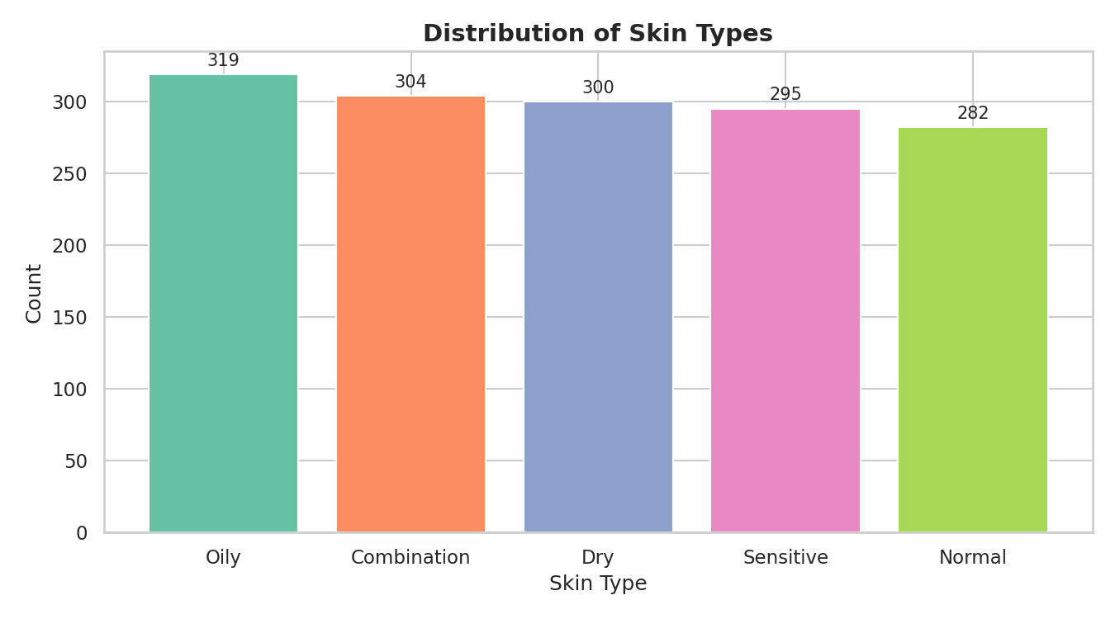

2.3.2 Acne Type Distribution
Acne type distribution reflects the class imbalance in the CNN image dataset: Blackheads is most common (448 records, corresponding to 735 training images) while Whiteheads is least frequent (135 records, corresponding to 193 training images). This imbalance will be corrected in Phase 3.

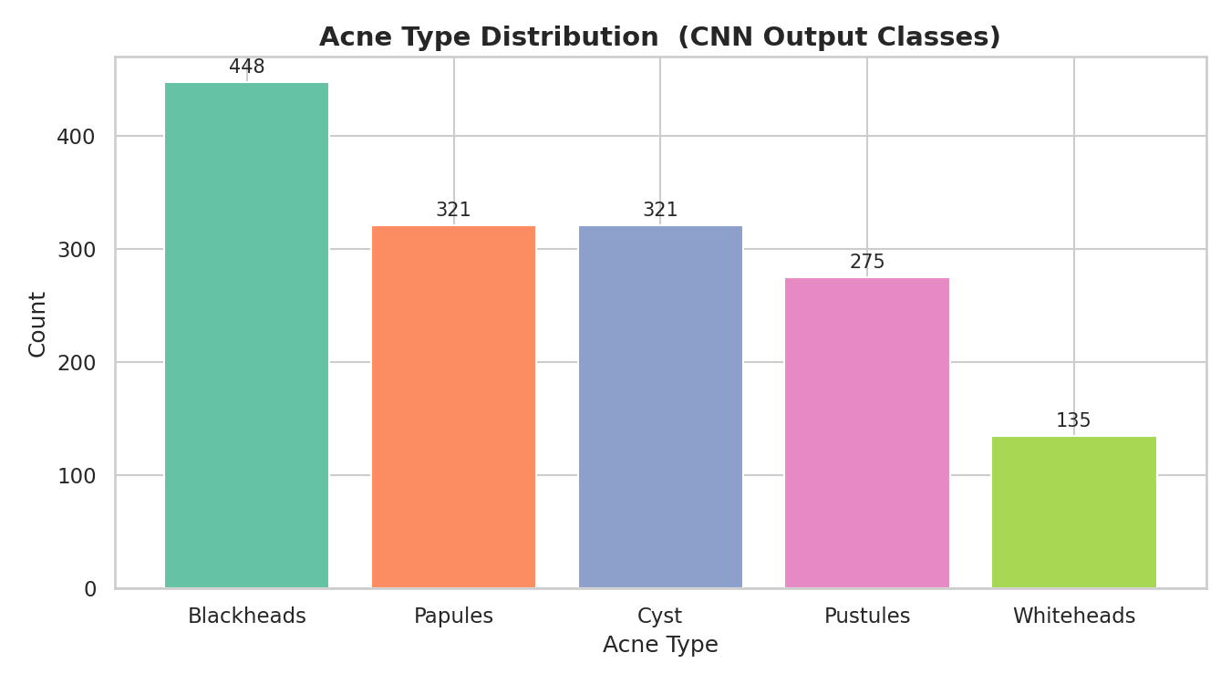

2.3.3 Acne Severity Distribution
Mild severity is most common (581 records), followed by Moderate (560) then Severe (359) — reflecting clinical reality. The distribution validates that the severity assignment rules in the generation script produce clinically realistic output.

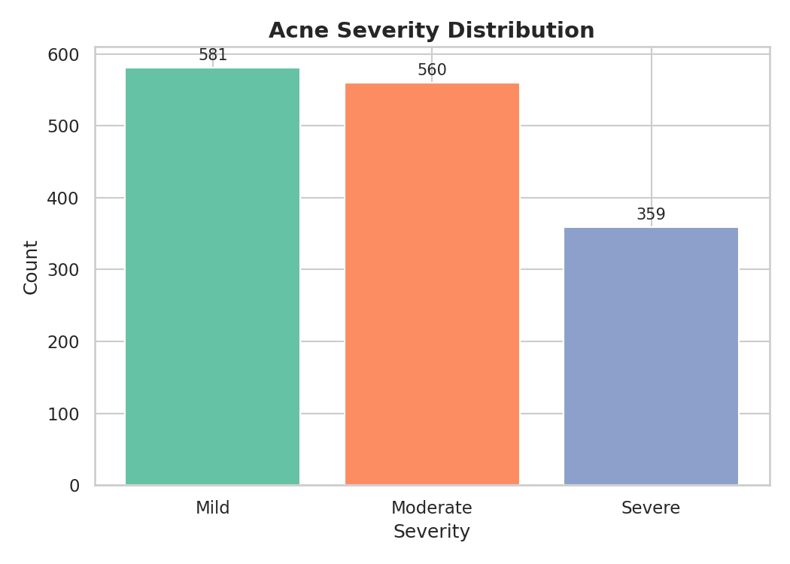

2.3.4 Recommended Treatment Distribution (Target Variable)
This is the most critical chart for model training. Soothing Cleanser (452) and Retinoid Treatment (423) dominate while Oil Control Moisturizer has only 10 records. This class imbalance will be corrected using SMOTE oversampling in Phase 3 to prevent the model from ignoring minority treatment classes.

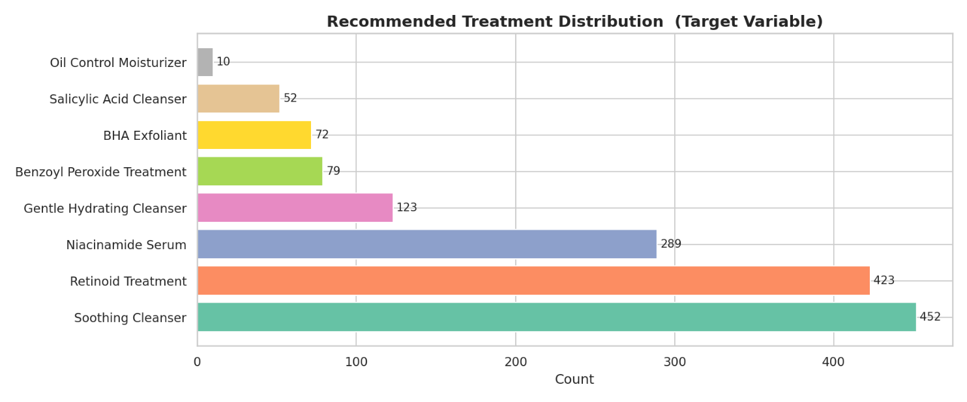

2.3.5 Skin Type vs. Acne Severity Heatmap
Sensitive skin records concentrate in Mild severity — clinically accurate, as sensitive skin rarely presents with severe inflammatory acne. Oily skin distributes across all severity levels. These patterns confirm the data generation rules produce clinically realistic combinations.

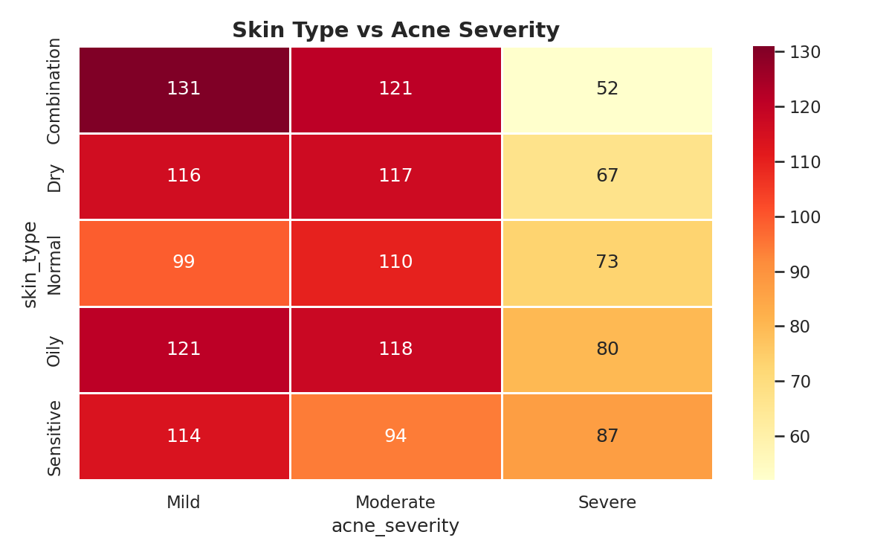

2.3.6 Acne Type vs. Recommended Treatment Heatmap
This chart validates the rule engine. Cystic acne concentrates in Benzoyl Peroxide Treatment and Retinoid Treatment — the strongest clinical interventions for inflammatory acne. Blackheads map to BHA Exfoliant and Salicylic Acid Cleanser. These meaningful patterns provide clear signals for the Random Forest model to learn from.

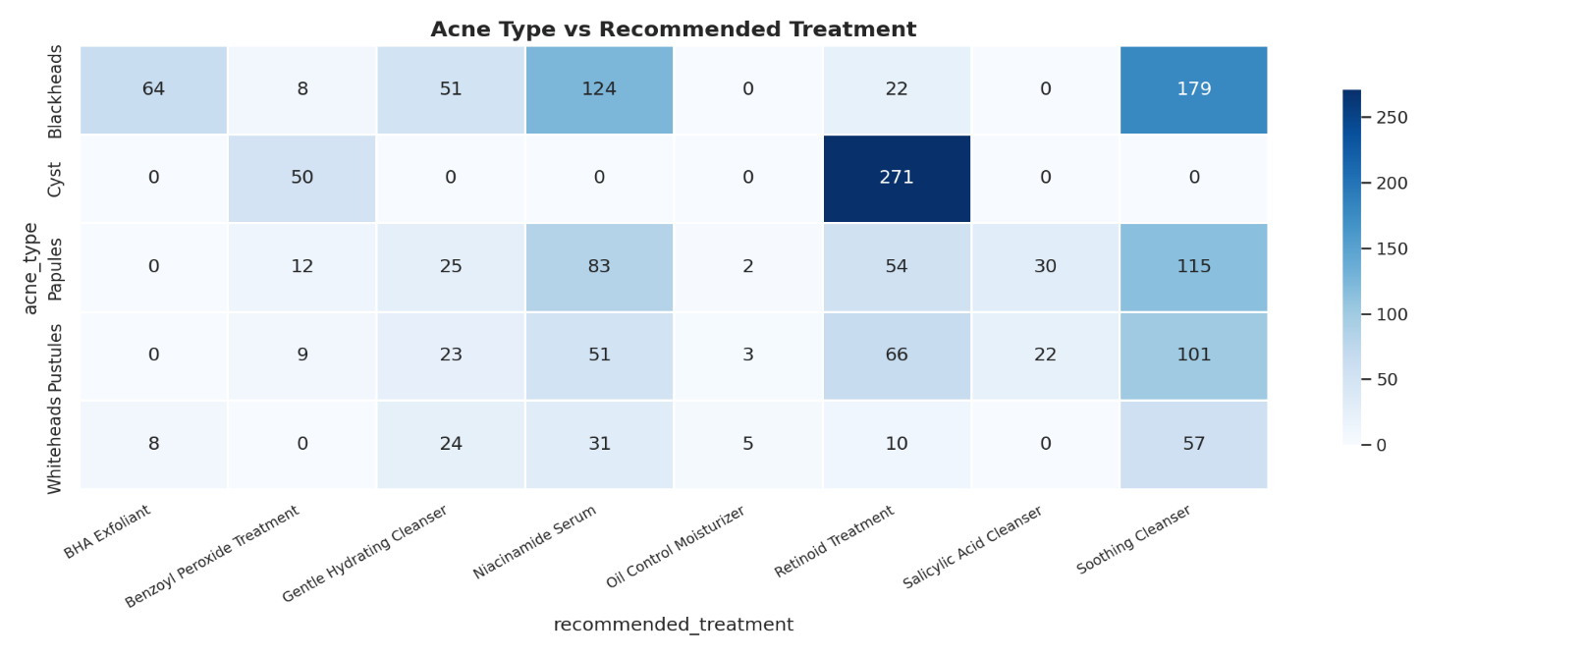

2.3.7 Hormonal Phase Distribution
'None' is the largest category at approximately 497 records (33%), representing male users and those who did not enter cycle data. The Luteal phase is particularly important as it is associated with hormonal acne and maps to Niacinamide Serum recommendations in the rule engine.

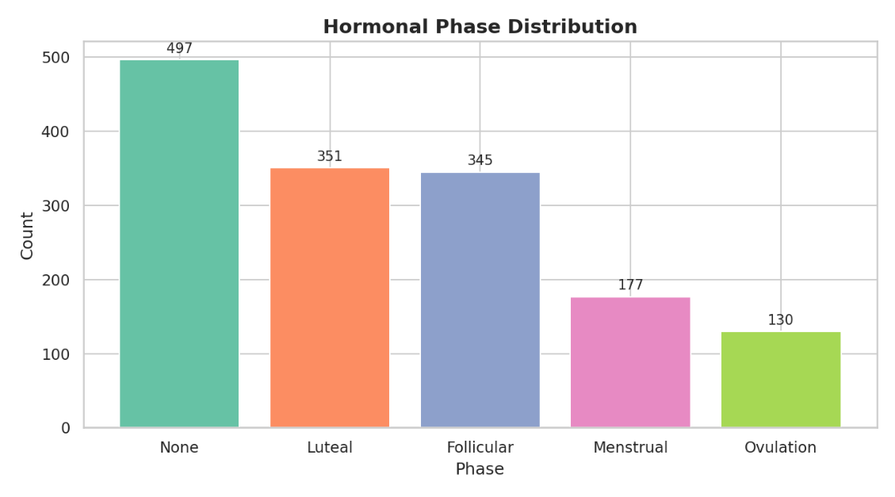

2.3.8 Breakout Location Distribution
Jawline and chin, the hormonal acne proxy in the recommendation rules, appears in a clinically realistic proportion (353 records). This feature allows the model to infer hormonal acne tendencies without requiring users to explicitly discuss their menstrual cycle.

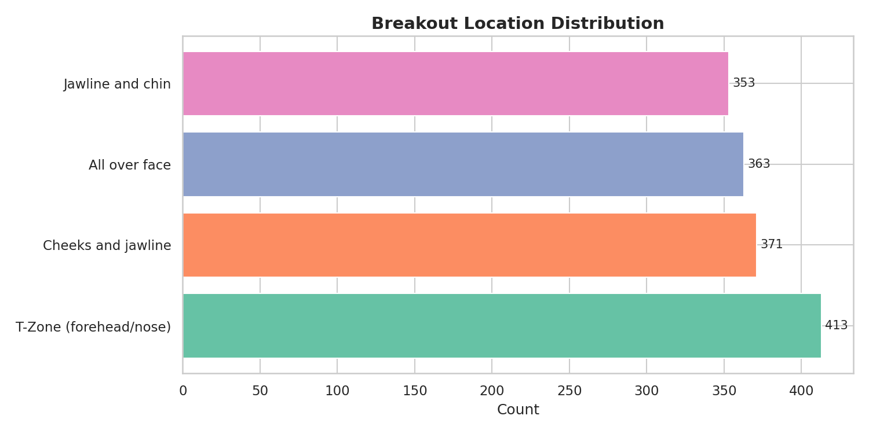

2.3.9 Allergen Distribution
'None' is most common (360 records), consistent with population-level surveys. Among specific allergens, Fragrance (297) and Parabens (293) are most prevalent — matching dermatological research identifying fragrance as the leading cosmetic allergen. This feature feeds directly into the product filtering logic in the recommendation output layer.

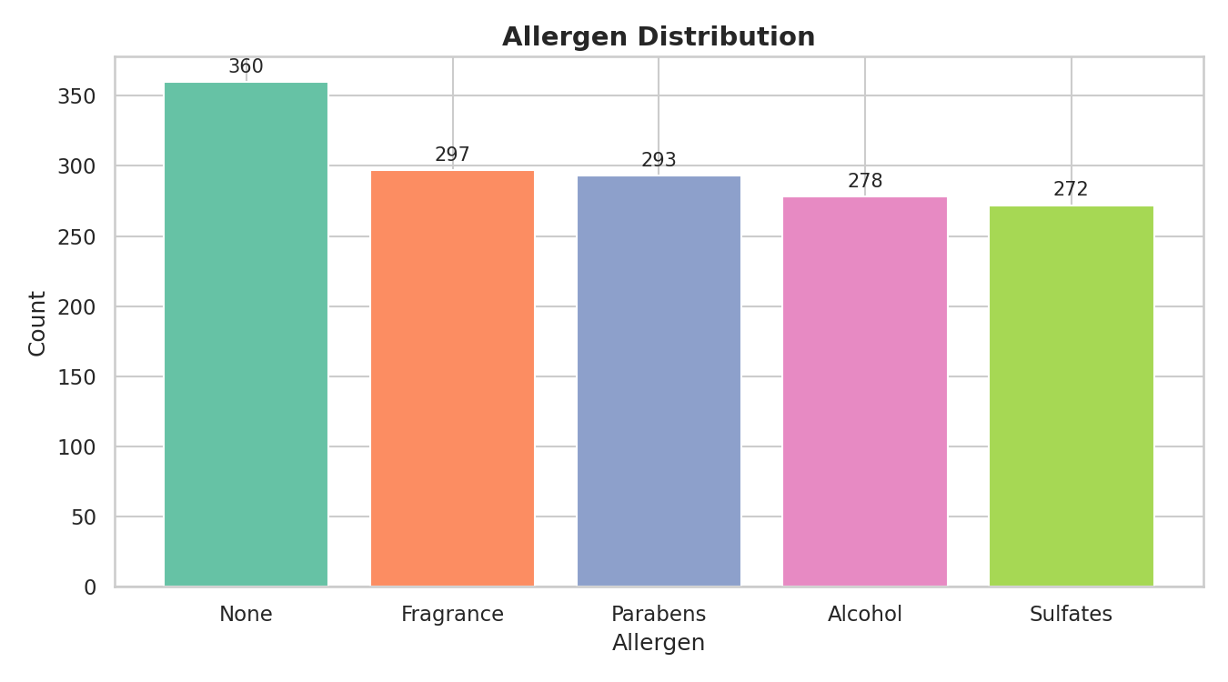

2.3.10 Feature Correlation Heatmap
The heatmap shows pairwise Pearson correlation coefficients between all 12 encoded and scaled features. The majority of feature pairs show values close to 0, indicating statistical independence. This is desirable for a Random Forest model as independent features each contribute unique predictive information. No pair exceeds ±0.7, so no feature removal is required on collinearity grounds.

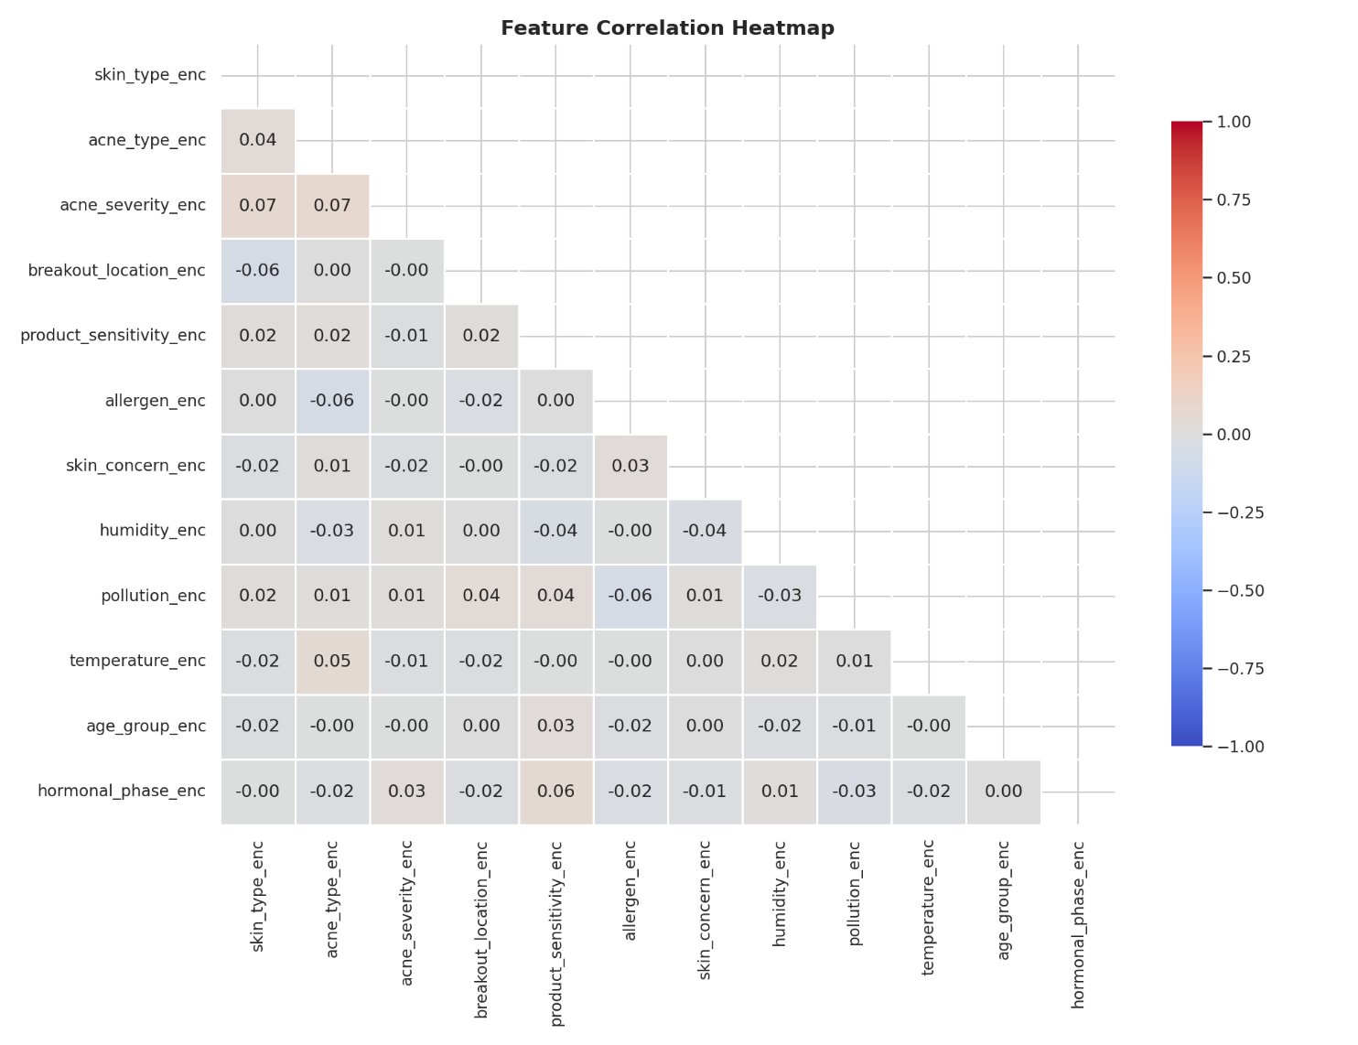

2.4 Phase 2 Summary

Requirement | What Was Done | Evidence
Data Collection | 4,617 dermatological images from Kaggle. 1,500 synthetic user profiles generated from dermatological rules. | Kaggle API script; generate_dataset_final.py
Cleaning: Duplicates | 30 user profile rows removed. Exact and near-duplicate images removed via MD5 and pHash. | Row count 1,530 → 1,500
Cleaning: Missing Values | hormonal_phase and allergen filled with 'None'. Other columns filled with mode. | user_profiles_clean.csv
Cleaning: Outliers | Categorical ranges controlled at generation. Image dimension outliers removed via thresholds. | generate_dataset_final.py
Feature Encoding | LabelEncoder on all 13 columns. Image labels encoded 0–4. | label_encoders.json
Feature Scaling | MinMaxScaler to [0,1] for profiles. Pixel /255 for images. | ml_ready_dataset.csv
EDA Visualizations | 10 charts for user profiles. Class distribution, dimension, RGB, and augmentation charts for images. | data/eda_charts/
Table 8: Phase 2 complete deliverables checklist

